Where’s the Money Going

Aim: Build a computer program/tool, working offline or online, that helps to visually analyze and trace the sources & destinations of multiple revenue and expenditures. Govt version : for public.

Note: this document is hereby shared under a [Creative Commons Attribution-ShareAlike 3.0 Unported License](http://creativecommons.org/licenses/by-sa/3.0/deed.en_US).

## Where it can be used

Originally intended for tracing public expenditures, this tool can be easily adapted for use in organisations as well.

## Demonstration of interface:

Main screen:

(note: the graphics can be in whichever way deemed fit… doesn’t have to be strictly this donut style. This was the best way I could represent it within MS Office)

If someone clicks on Education, next screen:

And clicking on Primary Ed

…and so on, to the lowest possible level where individual accounts start to show up (where available.. ex: MG Road repairs, July-Aug 2013). There’s a lot more that can be done on the visual part, but this is the basic idea.

I’ve shown percentages here, but with the real data the actual amount should also show.

An example on the web, using SVG vector drawing, can be seen here: <http://www.researchgate.net/>. Another example: <http://www.theguardian.com/environment/interactive/2013/nov/20/which-fossil-fuel-companies-responsible-climate-change-interactive> .

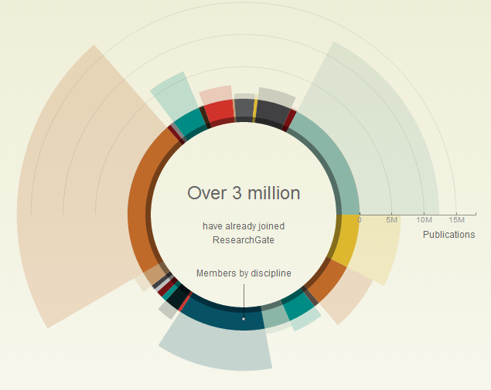

In this diagram, two number sets for the same categories are displayed: the length of the arc indicates number of people; and the width of the arc shows the number of publications. Similarly, we can use such a method to display expenditure as well as revenue, or number of employees vs expenditure, etc.

How can we get this data in a back-end? We would need a parent-child node table, like this:

|  |  |  |  |
| --- | --- | --- | --- |
| Id | Name of node | Parent node Id | Allotted expenditure |
| 1 | Main | 0 | 120000000 |
| 2 | Roads | 1 |  |
| 3 | National highways | 2 |  |
| 4 | State highways | 2 |  |
| 5 | Rural roads | 2 |  |
| 6 | Urban roads | 2 |  |
| 7 | Pavements | 6 |  |
| 8 | Lighting | 1 |  |

## Some variations from a simple parent-child node structure:

1. There may be a certain amount allotted to a node and all the individual expenses listed under the node may not add up. There may be undershoot or overshoot. If so, the tool should take cognizance of this fact and display it, with a certain colour / styling that catches the eye.

2. There might be no individual expenses recorded at all under a certain node. If clicked/opened, this node should then reveal a “black box” which demonstrates the fact.

3. Some nodes may be set to behave like the folder/directory in a computer: ie, they may derive their size purely from their constituent nodes and expenses. Ie, they may be bottom-up rather than top-down. In the visualization, such nodes should be marked differently. They may also be allotted a maximum expenditure limit, and it may be highlighted in case this limit has been crossed.

## Geographic data distribution:

The expenses can likely be split according to geographic area, in parallel with sectors. Even this can have parent-child relationships, like state > district > taluka or state > district > city > ward. In the tool we can have a sector mode and a map mode; and a map mode within a sector mode and vice versa.

So, by combining sectors and geography, with this tool a user can see the distribution of :

* expenditure on school equipment in primary education,
* in Pune city,
* with one view showing its breakdown into sub-sectors,
* and another view showing a map of pune city with amount and percentage distribution of clearly demarcated wards, for expenditure on school equipment in primary education.

The tool should be capable of handling no-data cases, example: expenditure on IIMs in Nasik district.

How the table might look:

|  |  |  |  |  |  |  |
| --- | --- | --- | --- | --- | --- | --- |
| Id | Name of node | Parent node id | Allotted expenditure | Geographical id | Parent geographical id | Geographical name |
| 1 | Main | 0 |  | 1 | 0 | India |
| 2 | Roads | 1 |  | 1 | 0 | India |
| 3 | State highways | 2 |  | 2 | 1 | Maharashtra |
| 4 | State highways | 2 |  | 3 | 1 | Gujarat |
| 5 | State highways | 2 |  | 4 | 1 | Rajasthan |
| 6 | State highways | 2 |  | 5 | 1 | Goa |
| 7 | State highways | 2 |  | 6 | 1 | Punjab |

## Seeing data with respect to time

* For any data being shown, there may be an option to see how it changed over different time periods.
* This can be done using a slider : move it and the objects on display change to update
* Or a graph: for one specific qty, variation over time.
* It should be possible to graphically compare an item between disparate time periods. Ex: Public schools, in 1993 and 2003.

## Comparison

For all kinds of data, there is an option to add them to a “comparison cart” akin to that seen in some online shopping sites. Once there, they may be seen in comparison.

Example 1: Expenditure on Public transport, compared among assembly constituencies in Pune:

It might be a good idea to add a checkbox for per-capita recalculation, when different geographical regions are being considered.

Taking it another level further, multiple components can be added up and compared across regions.

Example 2: Combined expenditure on public hospitals, aided hospitals, mid-day meal scheme, food subsidies, nutrition awareness programmes across assembly constituencies in Pune:

There may a lot of data per component that may not be able to display statically… for that a mouse-over display might help.

Example 3: Combined expenditure as above, this time with combined locations

There seem to stand out 2 distinct modes of comparison:

* Same nodes, different places
* Same places, different nodes

But I’d like to keep a watch for any others that may emerge. One example of a complicated comparison: change in per capita expenditure on transport related nodes over 5 years, compared between all rural and all urban areas in a state.

## Multi-level view:

In the WinDirStat program, relative sizes of folders and subfolders and their subfolders all the way down are shown graphically, helping us to trace anything unusual.

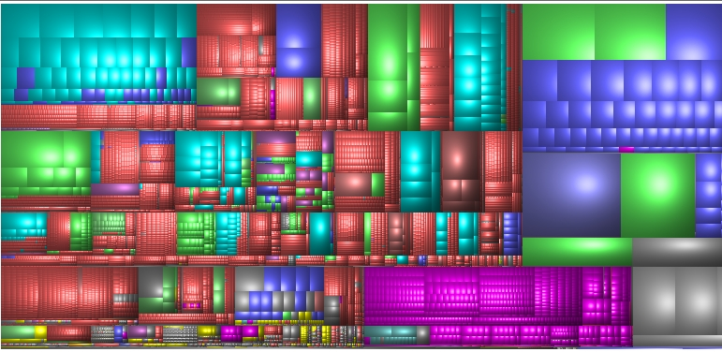

What if we could do that with expenditure or revenue breakdowns?

Such a diagram could also show black boxes where no further data is available, and help trace the white elephant expenditures, or the jackpot revenue sources.

To avoid over-complexity, levels can be specified : how many levels down to scan and show. (in the simple views described earlier, there’s only one level seen.)

This can help to catch the programs hogging more resources but delivering less impact, and to identify those delivering more impact while consuming less resources.

Similarly, revenue sources can help identify where greater revenue can come with lesser efforts or social costs. Example: bus fares vs. luxury goods duties.

## Printing

The tool should be able to give the user a PDF or image of what’s on display.

## Social angle

* Users can create a free account.
* Their customized data set selections are stored as templates for reuse and sharing with other users.
* They have an option to anonymize themselves and give a title to their templates when making their templates public.
* Every view has a social component below it… can range from a simple blog-style reply/comments thread to a proposal-vote space.
* Users can create and join groups for in-group discussions.

## Where is the data?

Well, I don’t have it yet. But it should be in public. This ought to be obtainable through RTI. The idea is to make it possible to make sense of the data that’s usually seen in huge tables, in separated bits and pieces and very hard to make sense of. So, let’s make the tool and have a space to bring the data in. And of course, the same tool can be used for any organization.

# Phase 2

Yes, there is a phase 2. This tool isn’t simply a reporting tool. Once the present data is displayed in all its glory, the user is given an opportunity to rethink the budget; to tweak the expenditure distributions all the way to the lowest node. At every change point they can write about why they feel this change should happen. They can even reduce some nodes to zero-allocation and introduce new expenditures.

Example: Setting up of community gardens in urban areas on terraces, that will employ local labor to grow food. Or elimination of subsidies for pesticides, citing known dangers to public health.

These tweaks will be made public, with the option to keep the user’s name anonymous. There can be discussions, voting around the same, and so users and groups of users can create, adopt and advocate proposed ‘citizen budget plans’.

Note: this document is hereby shared under a [Creative Commons Attribution-ShareAlike 3.0 Unported License](http://creativecommons.org/licenses/by-sa/3.0/deed.en_US).

October 17, 2013 | Project proposal by Nikhil VJ, Pune

Contact : nikhil.js@gmail.com, +91-9665831250